|  |
| --- |
| Coursework 2 Case Number CST2580 |
| Digital Incident Scene Investigation |
| Word Count: |

|  |
| --- |
| Presented by Josephine Dolor (M00644616), Abishen Gnanamuthu (M00664628), Samra Hamed (M00736899) & Israt Ahmed (M00737331)  4-11-2021 |

**Table of Contents**

**Executive Summary** 3

**1 Case Background** 4

**2 Standards Followed** 5

2.1 ISO Standards 5

**3 The Investigation** 6

3.1 Warrant 6

3.2 Search and Seizure 6

3.3 Interviews 8

3.4 Imaging 8

3.4.1 Tools Used During Acquistion 8

3.4.2 Imaging Jean’s Harddrive 9

3.4.3 Imaging The USB 10

3.4.4 Catalogue of Artifacts Submitted for Analysis 11

**4 Examination & Analysis** 13

4.1 Registry Information on Jean’s Hard Drive 14

4.2 Encryption 14

4.3 Keywords 15

4.4 Spreadsheet 15

4.4.1 Comparing the spreadsheets found 15

4.4.2 In-depth look at metadata of Spreadsheet 3 17

4.4.3 Spreadsheet contents 18

4.5 Emails 20

Email 1 20

Email 2 21

Email 3 22

Email 4 23

Email 5 24

Email 6 26

Email 7 27

Email 8 28

Email 9 28

Email 10 30

4.6 Installed Programs and Recycle Bin 32

4.7 Web Applications 32

**5 Summary of Findings** 34

**6 Conclusion** 35

**7 Appendices** 36

Appendix A – SEARCH WARRANT 36

Appendix B – CHAIN OF CUSTODY FORM FOR USB 38

Appendix C – CHAIN OF CUSTODY FORM FOR HARD DRIVE 39

Appendix D – DISK ACQUISITION FORMS 40

Appendix E – HARD DISK ACQUISITION FORM 41

Appendix F – USB ACQUISITION FORM 42

Appendix G – JEAN’S HARD DRIVE IMAGE SUMMARY 43

Appendix H – JEAN’S USB IMAGE SUMMARY 44

**8 References** 45

# **Executive Summary**

This report investigated the case of M57.Biz, regarding a leaked spreadsheet and the suspects involved. The report discussed the various steps taken to investigate the leak detailing the search, acquisition, and the analysis of evidence and findings.

A search warrant was executed in this investigation and the relevant acquisition forms were created for the devices seized. The evidence collected was Jean’s hard drive and a USB, which allowed the team to discover her emails, account information, and file systems stored. Images of the devices were made, which were analysed to find any evidential value and investigate further if needed.

During the analysis phase, the original spreadsheet containing an unfamiliar image and suspicious emails were discovered. The emails themselves were significant in the distribution of the spreadsheet. Malicious utilisation of employee accounts showed the company’s confidential information was leaked by spoofing. The role of the team was to investigate who was behind the spoofing and where the culprit(s) may have gotten assistance from. Data analysis was performed using a specialised software, such as Forensic Toolkit allowing the team to examine the case thoroughly

# **1 Case Background**

M57.Biz is an online art catalogue company that has been open for at least a year. With only 10 employees working for this small company, a confidential spreadsheet containing their names, salaries, and social security numbers has been found on their competitors firm’s website. It is understood that the spreadsheet was known to be in Jean Jones, Chief Financial Officer (CFO) sole possession, but she denied any involvement in the leak and did not know how it was shared: she claims that she must have been hacked.

Our team is composed by Case Officer Israt Jahan Ahmed, Warrant Officer Abishen Aloysius Gnanamuthu, Exhibit Officer Josephine Dolor and Forensic Investigator Samra Hamed, who were called to carry out a digital investigation and find the culprit. A search was conducted using Jean’s computer and the surrounding area, as we were informed this is where the spreadsheet was saved. Interviews took place with both Jean and the President, Allison Smith to establish how the data was stolen.

We concluded the following:

1. How did the documents get on the competitor's website?
2. When did Jean create this spreadsheet?
3. Who else from the company is involved?

# **2 Standards Followed**

During this investigation, established standards and principles were adhered to. These have been outlined below.

## 2.1 ISO Standards

One of the international standardisations for the digital forensics standards is ISO/IEC 27037 published in 2012. It provides the guidelines for the identification, collection, acquisition, and preservation of potential digital evidence that can be of evidential value. The standards also provide guidance to individuals and/or organisations that encounter digital evidence and assist them with procedures and processes to handle them accordingly. It assists organisations in their disciplinary procedures and in facilitating the exchange of potential digital evidence between jurisdictions.

In this case, ISO/IEC 27037:2012 gives guidance for several devices and one of which is for digital storage media used in computers (ISO, 2021). The two digital storage media identified and collected were a hard drive and USB stick. Moreover, this standard also gives guidance to the following devices and circumstances: Mobile phones; Personal Digital Assistants (PDAs); Personal Electronic Devices (PEDs); memory cards, Mobile navigation.

The ISO/IEC 17025:2015 is a mandatory standard for Digital Forensic laboratories in the UK as of October 2017. This standard is only applicable for the testing and calibration laboratories. Mainly, the standard provides the necessary process requirements such as method suitability, sampling, handling items, records, data, and information management (Forensic Notes, 2021).

ISO/IEC 27037 and ISO/IEC 17025 both provide standard and implemented guidelines which are applied in all our current and future digital investigation work, including the case in this report.

# **3 The Investigation**

## 3.1 Warrant

The use of search warrants is an important process in any investigation, as it requires the collection of evidence at the place or a vehicle where the incident has occurred. To obtain a search warrant it must be issued by a Magistrates’ Court and must be supported by evidence from the police under the Police and Criminal Evidence Act 1984 (PACE 1984), that the search warrant is necessary. When the Magistrate’s court issues a warrant, the search must be executed within three months (Gov.uk, 2020).

Using PACE 1984, a relevant warrant was issued to investigate this case further with the proper practice and protection of the public’s rights. It ensured that we (the investigators) and M57.Biz company (the occupiers) were both protected with the rights which were stated in the search warrant itself (The National Archives, 2021).

For this investigation, a search warrant was obtained for Room H104 at Middlesex University where M57.Biz company’s digital incident took place. The valid warrant provided us with the legal rights to gather evidence from the incident scene, assisting our investigation and preventing any discrepancies whilst the search was being undertaken. At the incident scene we carried out the search urgently since the investigation involved electronical devices that may require recording key dates and timestamps to assist with the investigation. Digital evidence is fragile; therefore, it is necessary to carry out an acceptable method that is suitable without affecting the integrity and authenticity of it. Therefore, certain processes were required in this investigation to ensure that the integrity of the digital evidence was maintained.

## 3.2 Search and Seizure

The search started on 14/01/2021 at 13:40 GMT, led by our searchers, Josephine Dolor and Samra Hamed.

We started by searching Jean’s computer, which was in its Basic Input/Output System (BIOS) state. We took a photograph of the screen and retrieved information such as the date and time, version and serial number to complete the disk acquisition form (Appendix D).

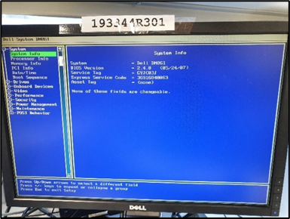

Figure 1 Jean's Desktop in BIOS state

At 13:48 GMT, we collected Jean’s hard drive by switching the computer off using the power button and taping over it. We disconnected and secured all cables and device ports from the back. Whilst unplugging the cables; we found a USB attached to the USB port on Jean’s CPU with the label ‘004’ at 13:49 GMT. Immediately, we photographed the USB and proceeded with the imaging and acquisition of the USB. Firstly, we used a Tableau T8-R2 write blocker and then at 13:52 GMT we started the imaging of the USB where the hashes were verified.

Once the image was verified, we moved with the acquisition of the USB, first we bagged and tagged the USB in bag number ‘0372473’, then proceeded by completing the chain of custody and acquisition forms for the USB (Appendix B and Appendix F).

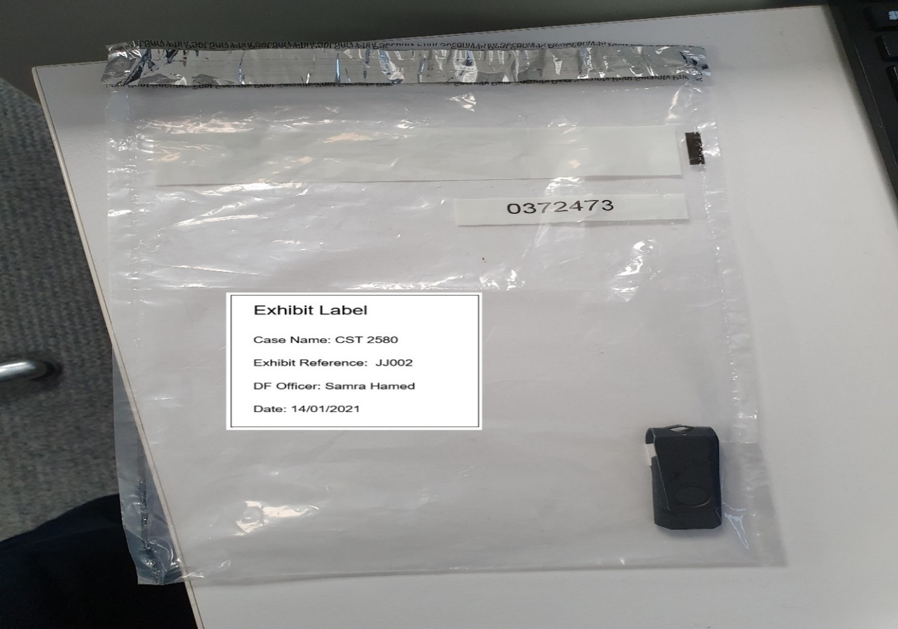

Figure 2 Seizure of Jean’s USB

We then proceeded with imaging and the acquisition of the hard disk. At 13:57 GMT, we acquired the hard disk and continued completing the chain of custody and acquisition forms (Appendix C and Appendix E), took photographs and used a write blocker to protect the integrity of the data. An image was created and the hashes were verified. We then bagged and tagged the hard disk in a bag number ‘0372474’ (see Figure 2).

## 3.3 Interviews

During the interview on 14th January 2021, Jean informed us she was the CFO of the company. She accessed her locked office using a key, which she did not share with anyone, therefore, the computer is left unattended once she leaves work. Network access is usually on when working and the computer can be accessed without a password. However, Jean claimed that she does not use any other devices nor works from home. Jean can use her username and password to access her work email, as it has been given by the company. To her knowledge, no other user has access to her email.

The spreadsheet containing employees’ names, salaries and background checks is kept by her on her device and email, no duplicates have been kept within the company. The spreadsheet was shared with Alison on 20th July 2020 via email and posted on the competitor’s company on 22nd July 2020. Bob, the programmer checked the device’s technical difficulties five minutes before us, the investigators, came and left it on BIOS mode. The device was not left unattended.

Whilst discussing with Alison about the shared post, she revealed that she had not asked Jean to send her any email regarding the spreadsheet with the employees’ information. However, Jean claimed that Alison has asked for the spreadsheet before the post appeared to deal with employees’ payments and making deals with banks. She was in town when the incident occurred. Similarly, to how Jean said that she does not wish to leave the company, Alison believes that her employees also do not want to leave the company. There were no links to competitors nor disputes for the whole year. However, Alison remains confused as to why Jean does not have password protection on her device as it has been provided.

## 3.4 Imaging

On discovery of Jean’s computer and USB, a physical image of each device was taken to ensure the integrity of the data was maintained.

### 3.4.1 Tools Used During Acquistion

Images are required to be taken with industry accepted devices and software to maintain integrity, and to allow the investigator to keep a detailed audit trail that can be repeated by a third party. We used the following to obtain these imaging results:

|  |  |  |
| --- | --- | --- |
| Software | 1. AccessData® FTK® Imager 3.4.2.6 2. Windows 10 Enterprise | 1. Imaging hard drive and USB 2. Host machine OS |
| Devices | 1. **Tableau T35U (Hard disk)** 2. **Tableau T8R2 (USB drive)** 3. **Dell Dimension DM061 PC i7-7700 16GB RAM** | 1. **Write blocker** 2. **Write blocker** 3. **Host machine for imaging** |

Figure 3 Table of tools and software used for acquisition stage

### 3.4.2 Imaging Jean’s Hard drive

Jean’s computer is where the original spreadsheet was said to be stored, therefore used for our investigation. As the computer was not to be taken from the incident scene, a physical image was taken instead. Pictures were taken of the device and its surrounding area prior to handling of any evidence.

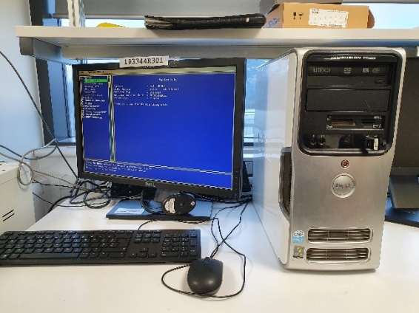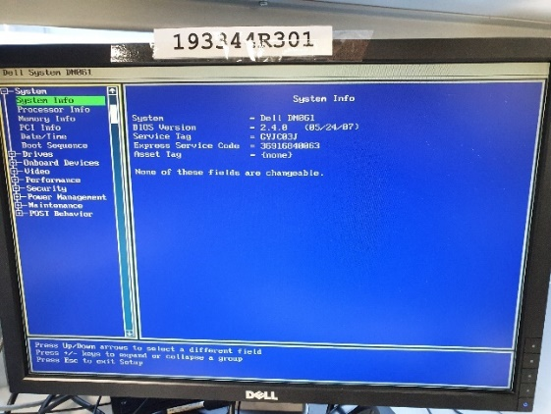

Figure 4 Jean's Desktop Displaying BIOS

At 13:44 GMT, the computer was discovered in the BIOS mode on the “System Info” tab, as seen in Figure 4. The computer found is a Dell Dimension DM061 PC with the service tag GYJC03J. The date and time displayed on the BIOS was “Thu Jan 14, 2021, 04:46:53 AM”. To ensure no malicious processes were triggered before an image was taken, the computer was turned off by removing the power cord directly from the back of the tower at 13:49 GMT. Once there was no power connectivity to the computer, the tower was carefully dismantled to allow us access to the hard drive. Each connected SATA/power cable was then disconnected, and the hard drive removed (see Figure 5).

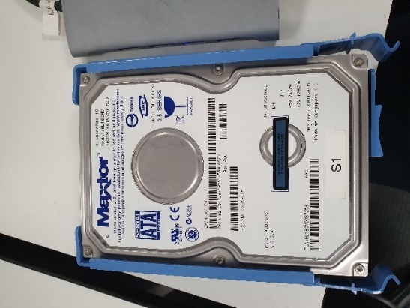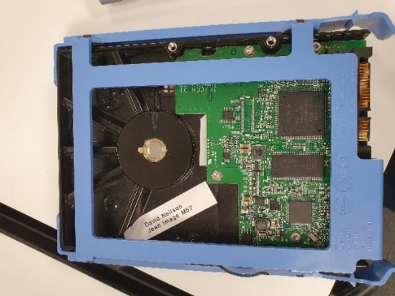

Figure 5 Jean's Hard Drive (Front & Back)

At 14:00 GMT, using the Tableau T35U write blocker, the hard drive was connected to the host Dell PC to acquire the image using the FTK Imager software. A write blocker was used during imaging to prevent any data being overwritten onto the suspected device, keeping it in its original state as found. Doing this maintains the integrity of the data and keeps any evidence found during analysis reliable and admissible in any subsequent cases.

A full image summary of the hard drive has been included in Appendix G.

### 3.4.3 Imaging the USB

During the initial inspection of Jean’s computer, other digital devices were searched for. The disk drive was checked, and no disks were present, however there was a USB connected to a front USB port of the tower (see Figure 6).

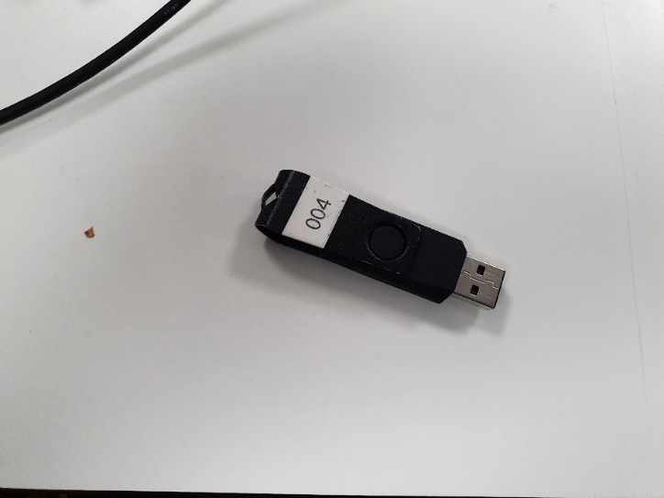

Figure 6 USB found in Jean's Computer, labelled 004.

As the investigation involved a piece of data being transferred in some form outside the company, it was reasonable to believe that a USB could have been used to delivery it. The only way to exclude it as a means of transport, was by the seizing and imaging the USB for analysis. This was done at 13:50 GMT. A full image summary of the USB has been included in Appendix H.

### 3.4.4 Catalogue of Artifacts Submitted for Analysis

**JEAN’S HARDRIVE PROPERTIES**

|  |  |
| --- | --- |
| Case Number | CST2580 |
| Evidence Number | JJ001 |
| Unique Description | Maxtor 3.5 Series DiamondMax 10 160GB HDD – Model 6L160M0 |
| Serial Number | L30AR0TH |
| Date & Time Imaged | 14/01/2021 at 14:00 GMT |
| Image Type | E01 |
| Image Size | 10240 MB |
| Computer MD5 Checksum | 78a52b5bac78f4e711607707ac0e3f93 |
| Image MD5 Checksum | 78a52b5bac78f4e711607707ac0e3f93 |
| MD5 Verification Status | **MATCH VERIFIED** |
| Computer SHA1 Checksum | ba7dc57e08bb6e3393aee15c713ae04feadcd181 |
| Image SHA1 Checksum | ba7dc57e08bb6e3393aee15c713ae04feadcd181 |
| SHA1 Verification Status | **MATCH VERIFIED** |

Figure 7 Hard drive properties and details of image

**USB PROPERTIES**

|  |  |
| --- | --- |
| Case Number | CST2580 |
| Evidence Number | JJ002 |
| Unique Description | USB found in Jean’s Computer, with label 004 |
| Drive Model | General UDisk USB Device |
| Date & Time Imaged | 14/01/2021 at 13:50 GMT |
| Image Type | Raw (dd) |
| Image Size | 507 MB |
| Computer MD5 Checksum | a5ecc193830f0a9480bf1f2c27a4a881 |
| Image MD5 Checksum | a5ecc193830f0a9480bf1f2c27a4a881 |
| MD5 Verification Status | **MATCH VERIFIED** |
| Computer SHA1 Checksum | 2fded8289c6d25e5977e43b5f577643791aaef52 |
| Image SHA1 Checksum | 2fded8289c6d25e5977e43b5f577643791aaef52 |
| SHA1 Verification Status | **MATCH VERIFIED** |

Figure 8 USB properties and image details

In both tables there is the phrase “MATCH VERIFIED”. For each hash values, this confirms the resulting image made matches the original data. If there are any changes made during the imaging process, this hash value would not match and means the copied data is compromised. A match allows any evidence found to be deemed present on the devices during the time of acquisition.

# **4 Examination & Analysis**

Investigations can lead to a large influx of data that may not be relevant to the case.

This investigation was concerned by analysing the evidence found on an existing spreadsheet obtained by an external party to determine the facts and to draw a reasonable conclusion. Only areas believed to be relevant to the leak were investigated, for example, the spreadsheet, emails, and the USB. Although these areas were focused on, each one may have taken focus into another area for further analysis.

The software and tools used for analysis are:

|  |  |  |
| --- | --- | --- |
| Software | 1. AccessData® Forensic Toolkit 6.0.3.5 2. Autopsy 3.1.2 3. Google Chrome 89.0.4389.82 4. Microsoft Outlook 16.46 5. Microsoft OneDrive 6. Microsoft Excel 16.0.13901.20148 7. MacOS Big Sur Version 11.2.3 8. Windows 10 Home | 1. To make data readable and analyse both images. 2. As an alternative check for results 3. Conduct web searches for context. 4. Analyse emails found. 5. Store findings and share with team. 6. Analyse spreadsheets. 7. MacBook Pro OS 8. VivoBook OS |
| Devices | 1. **VivoBook 15_ASUS Laptop X540MA_X540MA** 2. **MacBook Pro (Retina, 13-inch, Early 2015) 8GB RAM** | 1. **Host machine for analysis** 2. **Host machine for analysis** |

Figure 9 Software and devices used to process the image.

The images collected were made readable using the Forensic Toolkit software. A case folder dedicated to this investigation, “Forensic processing”, was created and customised. The options checked by default were kept, such as generating hash values and included deleted files. Flagging duplicate files were also added. The acquired image was loaded into the case for analysis to commence.

## 4.1 Registry Information on Jean’s Hard Drive

With the data in the image readable, the registry provided some system information.

|  |  |
| --- | --- |
| Operating System | Microsoft Windows XP – Service Pack 3 |
| Install Date | 13/05/2008 23:29:32 (2008-05-13 22:29:32 UTC) |
| Registered Owner | Jean User |
| Computer Account Name | JEAN-13FBF038A3 |
| Last Recorded Shutdown | 21/07/2008 02:31:32 (2008-07-21 01:31:32 UTC) |
| Number of Accounts | 10 (including 2 software and support services accounts |
| Last Accessed | Administrator (SID 500) - 21/07/2008 02:22:18 (2008-07-21 01:22:18 UTC)  Jean (SID 1004) - 20/07/2008 01:00:41 (2008-07-20 02:00:41 UTC)  Devon (SID 1007)– 12/07/2008 04:02:47 (2008-07-12 05:02:47 UTC)  Kim (SID 1003) – N/A  Addison (SID 1005) - N/A  Abijah (SID 1006) - N/A  Sacha (SID 1008) - N/A  Guest (SID 501) - N/A |
| Log In Counts | Administrator (24)  Jean (80)**  Devon (4) |

Figure 10 Key Registry information found.

## 4.2 Encryption

The user accounts from Jean’s hard drive were checked whether they were password protected to know if their data was encrypted. Using FTK, under the ‘explorer’ tab the root folder was selected to view the directories within. A folder named ‘CONFIG’ was opened to view the file list. Two registry files named ‘SAM’ and ‘system’ under this folder were individually exported to a case-assigned external folder. Using AccessData Password Recovery Toolkit, the NT Windows registry file ‘SAM’ were uploaded, and the ‘system’ file was uploaded as the start-key information for ‘SAM’ file. ‘Administrator’, ‘Devon’ and ‘Jean’ users were selected before starting the analysis. The password recovery finished analysing the identified user accounts and produced the results as ‘*empty*’. This indicated that the accounts did not have password protection set.

## 4.3 Keywords

Keywords were used to investigate the case and to narrow down the search, specific words were used such as ‘Social Security Number’, ‘SSN’ and ‘spreadsheet’. This helped the search be more effective, especially when key names were used such as ‘Jean’ and ‘Alison’.

## 4.4 Spreadsheet

The spreadsheet was an integral piece to this investigation as it was leaked in the comments section on the competitor’s website. On introduction to this incident, a copy of it was provided for reference purposes, see Figure 11.

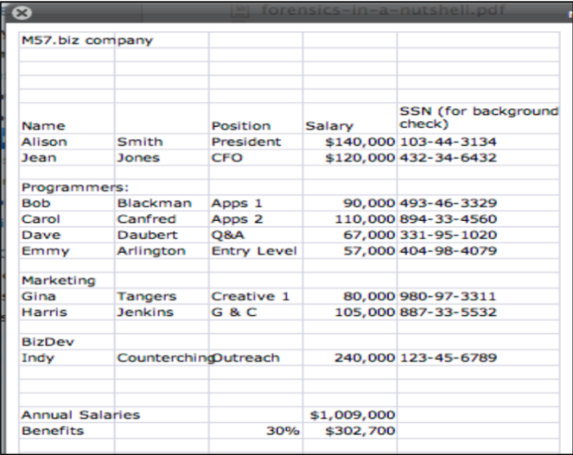

Figure 11 Spreadsheet provided from M57.Biz

Analysis began within Jean’s hard drive. From this, key factors were determined such as metadata to aid in finding out what could have happened.

To search for the spreadsheet on the system, Forensic Toolkit was used to navigate the “Overview” tab. In the spreadsheets section, 33 results were given. When examining the results, 3 files were discovered to contain the spreadsheet, all named “m57biz.xls”. The remaining spreadsheet files on the hard drive did not seem relevant to the current investigation. A bookmark was created called “Spreadsheet Files” to store new information, as well as files found through the options to include within the bookmarks tab. The spreadsheets were bookmarked with individual labels so that all files related to them could be matched to the correct version.

### 4.4.1 Comparing the spreadsheets found

Analysis of the metadata for the versions was conducted with the below findings:

**SPREADSHEET 1**

|  |  |
| --- | --- |
| Filename | m57biz.xls |
| Path | Jane001.E01/Partition 1/NONAME [NTFS]/[root]/Documents and Settings/Jean/Local Settings/Application Data/Microsoft/Outlook/outlook.pst»Personal Folders»Sent Items»RE: Please send me the information now»m57biz.xls |
| Physical Size | n/a |
| Logical Size | 295,439 bytes (288.5 KB) |
| Date Created | 20/07/2008 02:28:03 (2008-07-20 01:28:03 UTC) |
| Date Accessed | n/a |
| Date Modified | 20/07/2008 02:28:03 (2008-07-20 01:28:03 UTC) |
| Actual File | False |
| Duplicate File | Secondary |
| From Email | True |
| MD5 Hash | e23a4eb7f2562f53e88c9dca8b26a153 |
| SHA1 Hash | 55638af43dddd0f1ff8cd4dab73b2979ac5be8b1 |

Figure 12 Data found in Spreadsheet 1 Bookmark file

**SPREADSHEET 2**

|  |  |
| --- | --- |
| Filename | m57biz.xls |
| Path | Jane001.E01/Partition 1/NONAME [NTFS]/[root]/Documents and Settings/Jean/Local Settings/Application Data/Microsoft/Outlook/outlook.pst»Personal Folders»Top of Personal Folders»Sent Items»RE: Please send me the information now»m57biz.xls |
| Physical Size | n/a |
| Logical Size | 295,439 bytes (288.5 KB) |
| Date Created | 20/07/2008 02:28:03 (2008-07-20 01:28:03 UTC) |
| Date Accessed | n/a |
| Date Modified | 20/07/2008 02:28:03 (2008-07-20 01:28:03 UTC) |
| Actual File | False |
| Duplicate File | Secondary |
| From Email | True |
| MD5 Hash | e23a4eb7f2562f53e88c9dca8b26a153 |
| SHA1 Hash | 55638af43dddd0f1ff8cd4dab73b2979ac5be8b1 |

Figure 13 Data found in Spreadsheet 2 Bookmark file

**SPREADSHEET 3**

|  |  |
| --- | --- |
| Filename | m57biz.xls |
| Path | Jane001.E01/Partition 1/NONAME [NTFS]/[root]/Documents and Settings/Jean/Desktop/m57biz.xls |
| Physical Size | 294,912 bytes (288.0 KB) |
| Logical Size | 291,840 bytes (285.0 KB) |
| Date Created | 20/07/2008 02:28:03 (2008-07-20 01:28:03 UTC) |
| Date Accessed | 20/07/2008 02:28:03 (2008-07-20 01:28:03 UTC) |
| Date Modified | 20/07/2008 02:28:03 (2008-07-20 01:28:03 UTC) |
| Actual File | True |
| Duplicate File | Primary |
| MD5 Hash | e23a4eb7f2562f53e88c9dca8b26a153 |
| SHA1 Hash | 55638af43dddd0f1ff8cd4dab73b2979ac5be8b1 |

Figure 14 Data found in Spreadsheet 3 Bookmark file

The tables above suggest three different file paths for the documents, however only spreadsheet three is stored physically on Jean’s device with a physical size of 288KB assigned to it. Verifying that all three files are the exact same document, the hash value of each one was compared. All three matched with these values:

1. MD5 Hash – **e23a4eb7f2562f53e88c9dca8b26a153**
2. SHA1 Hash – **55638af43dddd0f1ff8cd4dab73b2979ac5be8b1**

The other two come from her mail client Outlook, within her sent folders. This supports the need for further investigation into her emails as this is evidence that she has sent it via emails (see section 4.5). The file stored on her computer is also the only one listed as accessed and primary, so further analysis can be carried out to provide more clues.

### 4.4.2 In-depth look at metadata of Spreadsheet 3

Looking into the metadata from Microsoft Office (Figure 15), there is some inconsistent data that raises suspicions. Firstly, the author of the document is listed as Alison Smith in the Microsoft Office metadata. We were told that Jean was the only person that has had anything to do with this spreadsheet, but Alison may have been the creator. However, there could be many explanations for this such as, the MS Excel software she has used could have automatically assigned Alison as creator or that Alison had sent over a file that she had already created, which Jean may have further edited. This factor alone did not definitively show malicious intent.

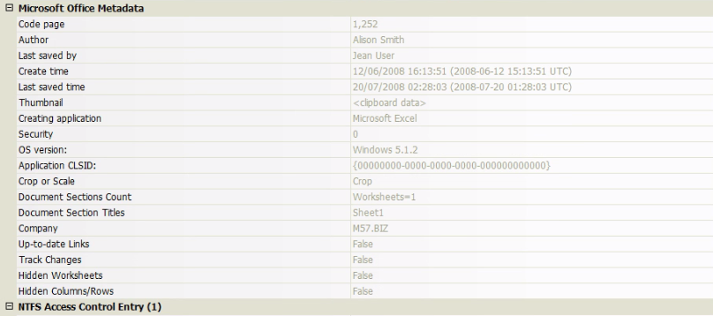

Figure 15 Microsoft Office metadata for Spreadsheet 3

As expected, the last saved by is listed as “Jean User”, no indication of suspicious activities. However, the create time is noted as **“12/06/2008 16:13:51 (2008-06-12 15:13:51 UTC)”** in the Microsoft metadata. This is over a month earlier than the file systems suggestion of **“20/07/2008 02:28:03 (2008-07-20 01:28:03 UTC)”**. The fact that the two dates differ suggests that someone had intentionally altered the metadata to hide their actions.

### 4.4.3 Spreadsheet contents

For better understanding, the contents of the file were analysed. Examining the spreadsheet in its entirety revealed an image that had been pasted into the file (see Figure 16). It seems unusual that a company would insert an image like this into a confidential file. This, coupled with the changing of the metadata, may be reason to believe Jean’s computer was compromised in some way.

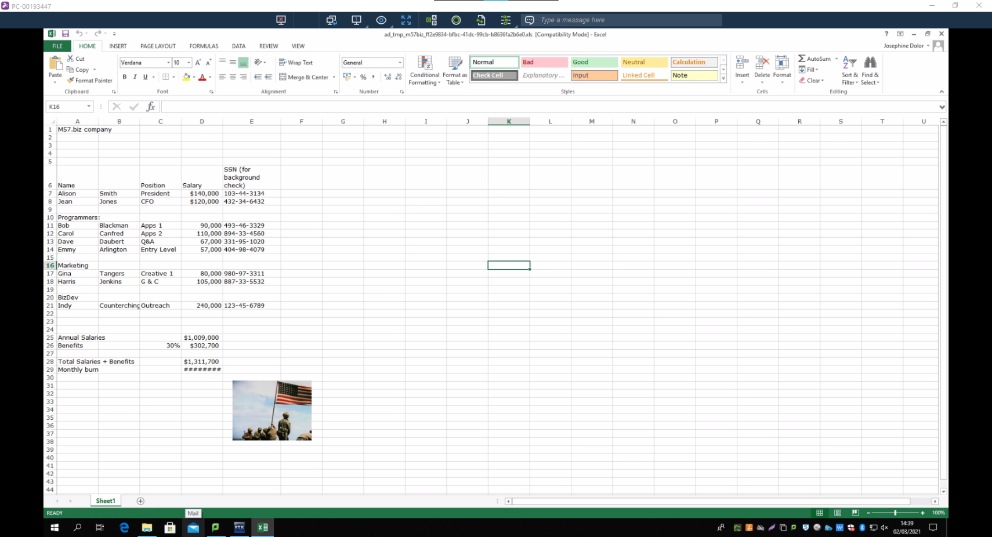

Figure 16 Full View of Leaked Spreadsheet

To see whether the image holds deeper meaning, the image was saved, and a reverse lookup conducted on Google. The top results can be seen in Figure 17. According to the results, the image is taken from a video by Sergeant Genaust that depicts a famous photograph named “Raising the Flag on Iwo Jima” by Joe Rosenthal. The image was captured during America’s invasion of Iwo Jima, a significant step in its fight against Japan during the Pacific War. Iwo Jima was used by the Japanese as an early warning system for approaching enemy troops. America’s invasion was a big hit to Japanese defences. The flag was raised on the best vantage point of the island (Wikipedia, 2021). It could be possible this is the reason why it was saved in the spreadsheet, as a hidden message of an early warning system of what was to come, or a boast that they were able to penetrate M57.Biz’s defences and win. Whatever the reasons, they cannot be determined without further investigation into how the image got on the spreadsheet.

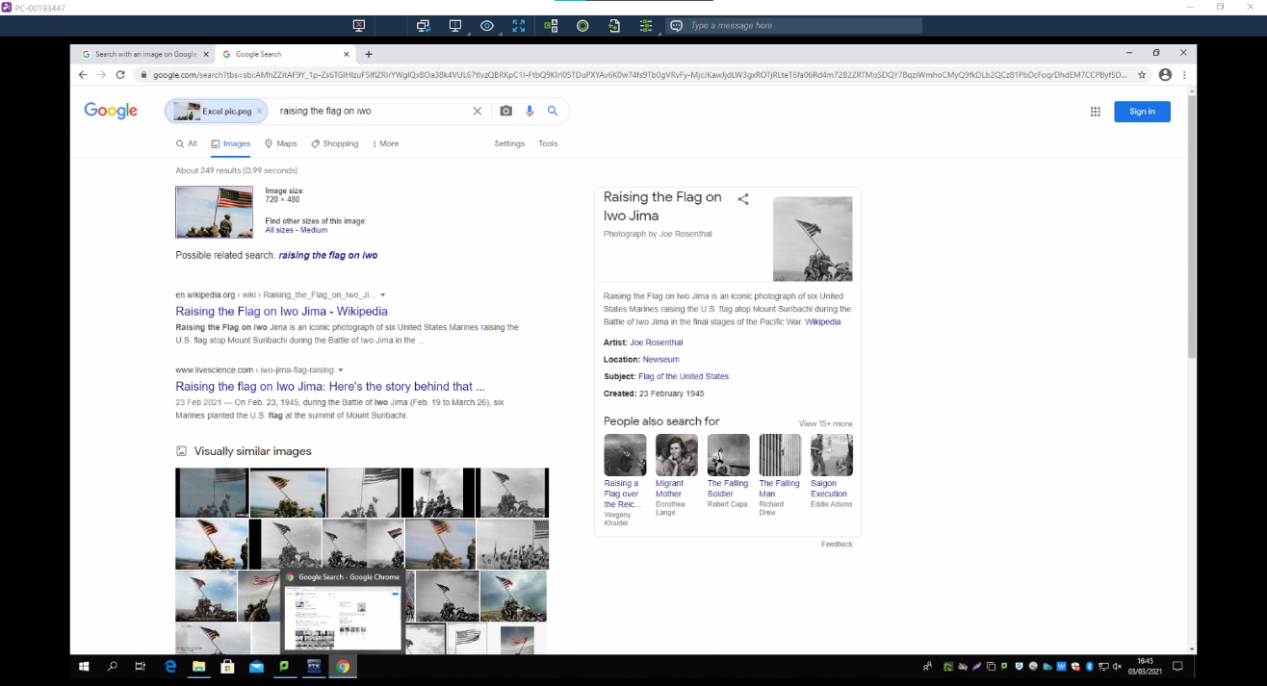

Figure 17 Reverse Image Lookup Results

After searching the 8,118 graphics on the hard drive, a few images of the American flag on its own were found, but none of this specific image.

## 4.5 Emails

Email analysis was performed during this investigation as the company’s main method of communication is via email. Like many other organisations, it is a professional method of contacting clients and staff within a secure database. As M57.Biz uses email to communicate within a working environment, they have their own email domain of their company’s name. Therefore, the email headers of each email sent from Alison’s computer were investigated. Using the imaged file from the evidence, specific keywords were analysed to help retrieve information faster.

### 4.5.1 Email 1

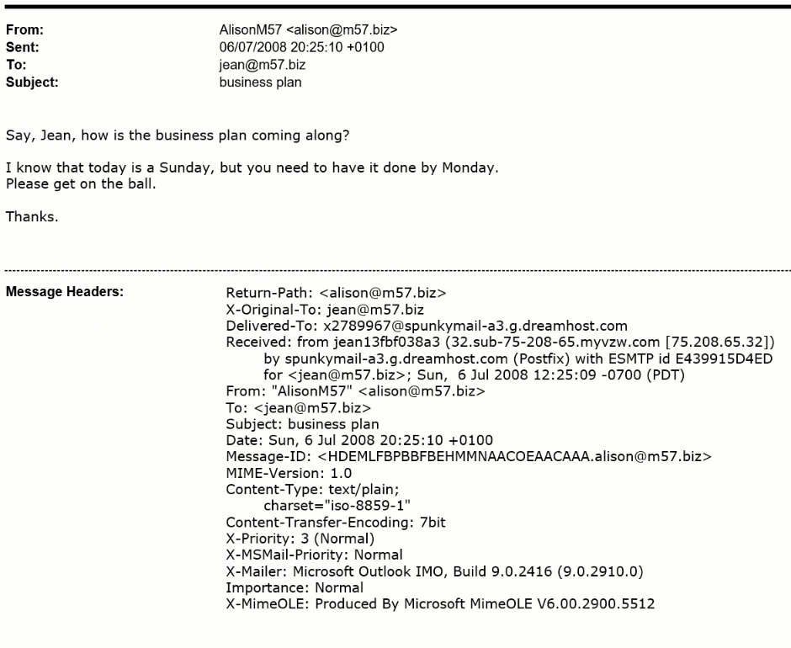

Figure 18 From Alison to Jean ‘business plan’

As shown in Figure 18, the email regards a business arrangement between Alison and Jean, which seems to be trustworthy. Both the Return-Path and the Message-ID match as an m57.biz account. Therefore, Alison’s Message-ID can be identified as [HDEMLFBPBBFBEHMMNAACOEAACAAA.alison@m57.biz](mailto:HDEMLFBPBBFBEHMMNAACOEAACAAA.alison@m57.biz).

The Received header and the Delivered-to header have the sender’s email address as dreamhost.com to send the message along with its IP address 75.208.65.32. The IP address is checked using a DNS lookup to check the consistency of the connection. ESMTP id E439915D4ED increases the reliability of the email as it is the record of the device’s server. The X-Original-To header and To header are addressed to [jean@m57.biz](mailto:jean@m57.biz), which means the email reaches its destination.

MIME-Version is 1.0 and Content-type is text/plain. No documents have been attached.

### 4.5.2 Email 2

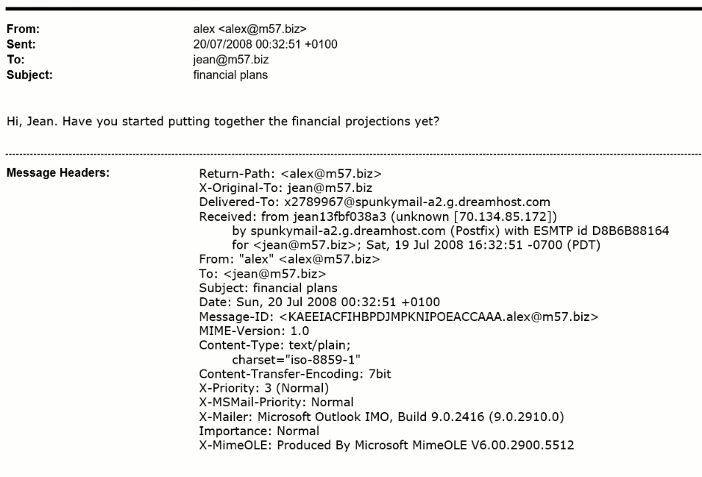

Figure 19 From Alex to Jean ‘financial plans’

As shown in Figure 19, the email discusses the financial plans between Alex and Jean. Both the Return-Path and the Message-ID match as an m57.biz account. Therefore, Alex’s Message-ID can be identified as [KAEEIACFIHBPDJMPKNIPOEACCAAA.alex@m57.biz](mailto:KAEEIACFIHBPDJMPKNIPOEACCAAA.alex@m57.biz).

The Received header and the Delivered-to header have the sender’s email address as dreamhost.com to send the message along with an unknown router and IP address 70.134.85.172. A DNS lookup to check the consistency of the connection would not be useful. Even though the ESMTP id D8B6B88164 increases the reliability of the email as it is the record of the device’s server, since the router is unspecified and Alex is not an employee of m57.biz company, the email can be assumed to be untrustworthy. The X-Original-To header and To header are addressed to [jean@m57.biz](mailto:jean@m57.biz), which means the email reaches its destination.

MIME-Version is 1.0 and Content-type is text/plain. No documents have been attached.

### 4.5.3 Email 3

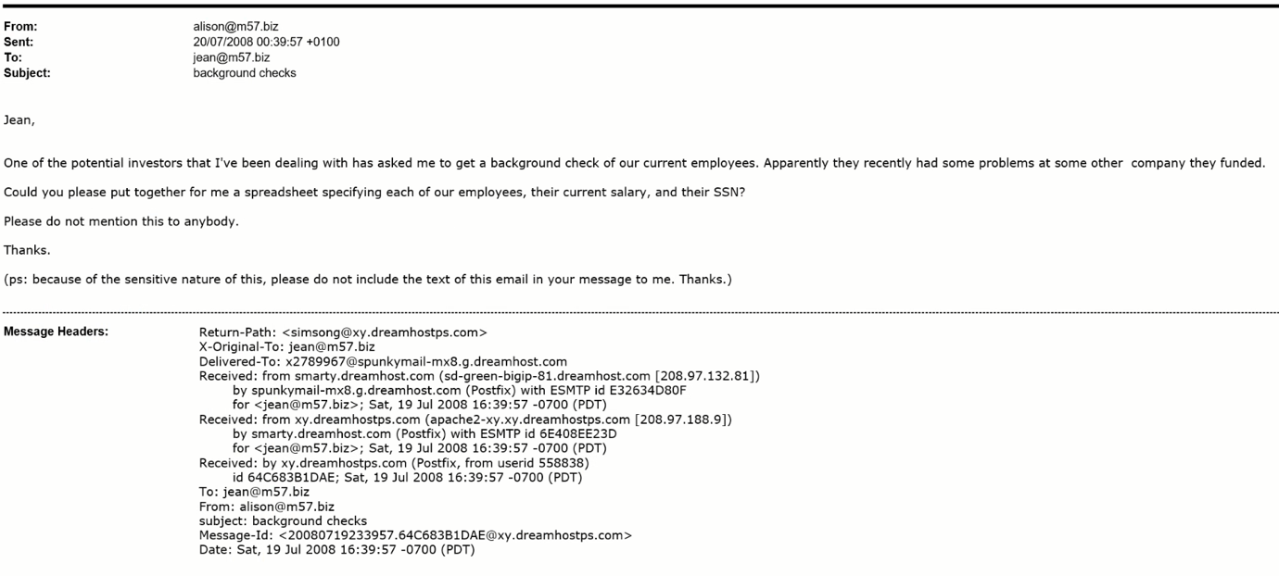

A

B

C

Figure 20 From Alison to Jean ‘background checks’

As shown in Figure 20, the email discusses about providing a spreadsheet with employees and their details between Alison and Jean.

Both the Return-Path and the Message-ID match as an @xy.dreamhostps.com account. However, the email can be assumed to be untrustworthy as Alison’s Message-ID ends in [alison@m57.biz](mailto:alison@m57.biz), whereas Message-ID of the Figure is [20080719233957.64C683B1DAE@xy.dreamhostps.com](mailto:20080719233957.64C683B1DAE@xy.dreamhostps.com). The email can be assumed to have been sent by a third party.

Moreover, even though Received header A and B have the sender’s email address as xy.dreamhostps.com, Received header A does not have an IP address, whereas Received header B uses IP address 208.97.188.9, which can be checked using a DNS lookup to check the consistency of the connection. Received header A and B have different ids. Received header A has id 64C683B1DAE, which cannot be tested, whereas Received header B has ESMTP id 6E408EE23D. Reliability can be increased as it is a record of the device’s server. However, since Received header A and Received header B are inconsistent, it can be assumed the message sent as an untrustworthy spam email.

The Received header C and the Delivered-to header have the sender’s email address as dreamhost.com to send the message along with its IP address 208.97.132.81. The IP address is checked using a DNS lookup to check the consistency of the connection. ESMTP id E32634D80F increases the reliability of the email as it is the record of the device’s server, even though it has been already established to be a spam email. Both X-Original-To header and To header are addressed to reach its destination, which is [jean@m57.biz](mailto:jean@m57.biz).

### 4.5.4 Email 4

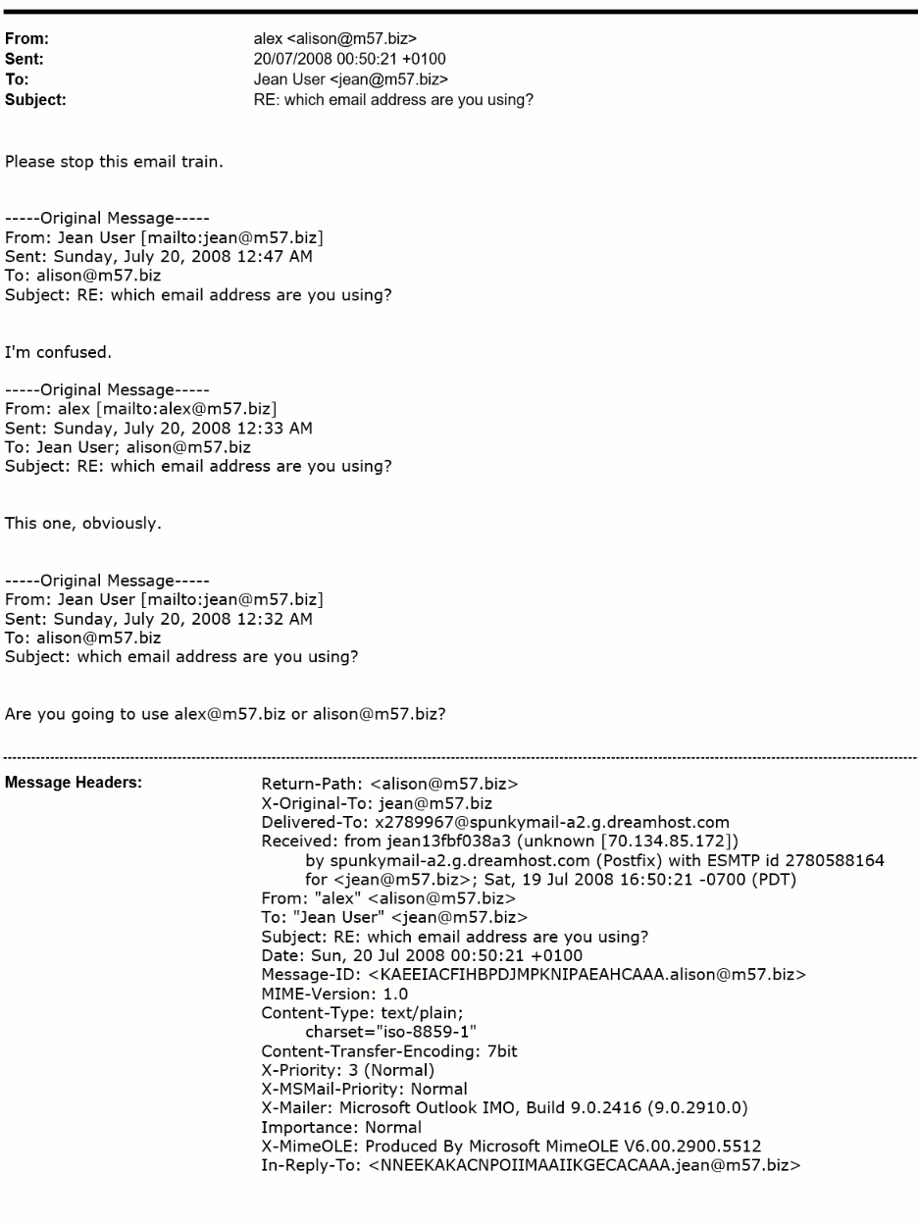

Figure 21 From Alex to Jean ‘which email address are you using?’

As shown in Figure 21, the email represents communication about the email that is being used by Alison, between Jean and Alison. Both the Return-Path and the Message-ID match as an m57.biz account. However, it can already be assumed that the untrustworthy as shown by the fact that Alison’s email address has been replaced by the name Alex along with his Message-ID, which can be identified as [KAEEIACFIHBPJDJMPKNIPOEACCAAA.alex@m57.biz](mailto:KAEEIACFIHBPJDJMPKNIPOEACCAAA.alex@m57.biz), similar to Figures 19.

The Received header and the Delivered-to header have the sender’s email address as dreamhost.com to send the message along with an unknown router and IP address 70.134.85.172. A DNS lookup to check the consistency of the connection would not be useful. Even though the ESMTP id 2780588164 increases the reliability of the email as it is the record of the device’s server, since the router is unspecified and Alison has been replaced by the user Alex, who is not an employee of m57.biz company, the email is untrustworthy. The X-Original-To header and To header are addressed to [jean@m57.biz](mailto:jean@m57.biz), which means the email reaches its destination. In-Reply-To header is [NNEEKAKACNPOIIMAAIIKMEAACAAA.jean@m57.biz](mailto:NNEEKAKACNPOIIMAAIIKMEAACAAA.jean@m57.biz) as it is a reply to Jean’s email address similar to Figures 11 and 15.

MIME-Version is 1.0 and Content-type is text/plain. No documents have been attached.

### 4.5.5 Email 5

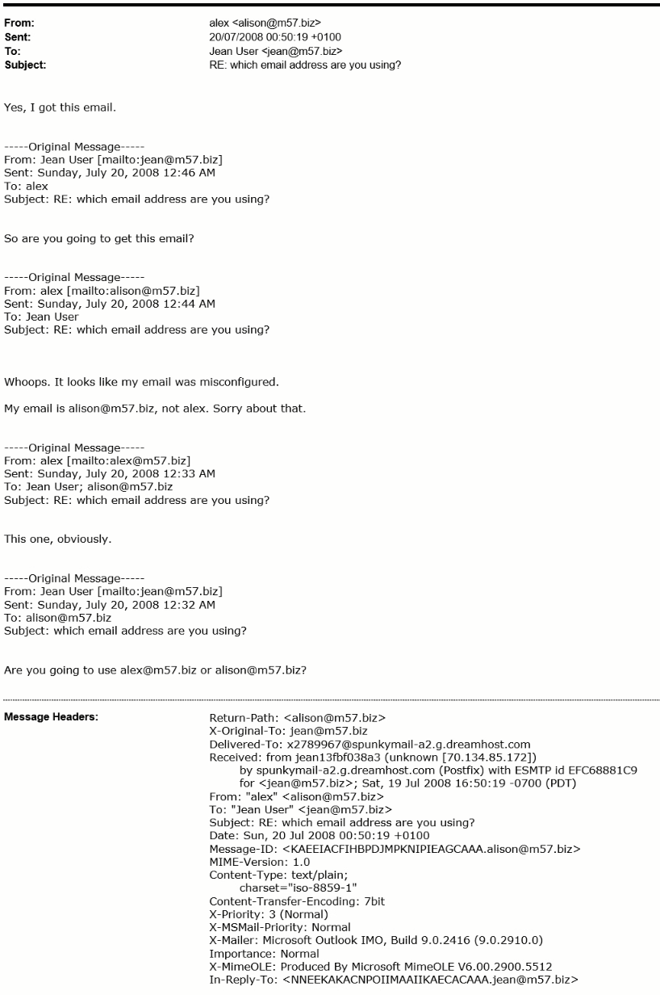

Figure 22 From Alison to Jean ‘which email address are you using?’

As shown in Figure 22, the email represents communication about the email that is being used by Alison, between Jean and Alison. Both the Return-Path and the Message-ID match as an m57.biz account. However, it can already be assumed that the untrustworthy as shown by the fact that Alison’s email address has been replaced by the name Alex along with his Message-ID, which can be identified as [KAEEIACFIHBPDJMPKNIPIEAGCAAA.alex@m57.biz](mailto:KAEEIACFIHBPDJMPKNIPIEAGCAAA.alex@m57.biz), similar to Figures 19 and 21.

The Received header and the Delivered-to header have the sender’s email address as dreamhost.com to send the message along with an unknown router and IP address 70.134.85.172. A DNS lookup to check the consistency of the connection would not be useful. Even though the ESMTP id EFC68881C9 increases the reliability of the email as it is the record of the device’s server, since the router is unspecified and Alison has been replaced by the user Alex, who is not an employee of m57.biz company, the email is untrustworthy. The X-Original-To header and To header are addressed to [jean@m57.biz](mailto:jean@m57.biz), which means the email reaches its destination. In-Reply-To header is [NNEEKAKACNPOIIMAAIIKAECACAAA.jean@m57.biz](mailto:NNEEKAKACNPOIIMAAIIKAECACAAA.jean@m57.biz) as it is a reply to Jean’s email address similar to Figure 21.

MIME-Version is 1.0 and Content-type is text/plain. No documents have been attached.

### 4.5.6 Email 6

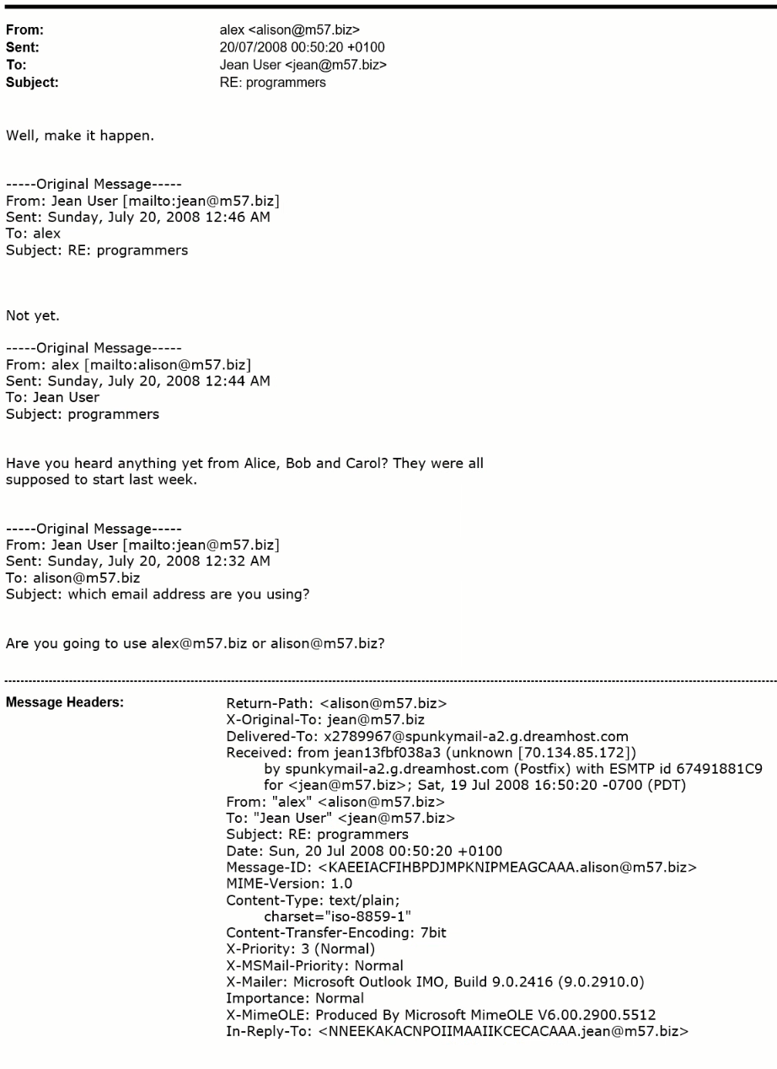

Figure 23 From Jean to Alison ‘programmers’

As shown in Figure 23, the email represents communication about programmers between Jean and Alison. Both the Return-Path and the Message-ID match as an m57.biz account. However, it can already be assumed that the untrustworthy as shown by the fact that Alison’s email address has been replaced by the name Alex along with his Message-ID, which can be identified as [KAEEIACFIHBPDJMPKNIPMEAGCAAA.alex@m57.biz](mailto:KAEEIACFIHBPDJMPKNIPMEAGCAAA.alex@m57.biz), similar to Figures 19, 21 and 22.

The Received header and the Delivered-to header have the sender’s email address as dreamhost.com to send the message along with an unknown router and IP address 70.134.85.172. A DNS lookup to check the consistency of the connection would not be useful. Even though the ESMTP id 67491881C9 increases the reliability of the email as it is the record of the device’s server, since the router is unspecified and Alison has been replaced by the user Alex, who is not an employee of m57.biz company, the email is untrustworthy. The X-Original-To header and To header are addressed to [jean@m57.biz](mailto:jean@m57.biz), which means the email reaches its destination. In-Reply-To header is [NNEEKAKACNPOIIMAAIIKCECACAAA.jean@m57.biz](mailto:NNEEKAKACNPOIIMAAIIKCECACAAA.jean@m57.biz) as it is a reply to Jean’s email address similar to Figures 21 and 22.

MIME-Version is 1.0 and Content-type is text/plain. No documents have been attached.

### 4.5.7 Email 7

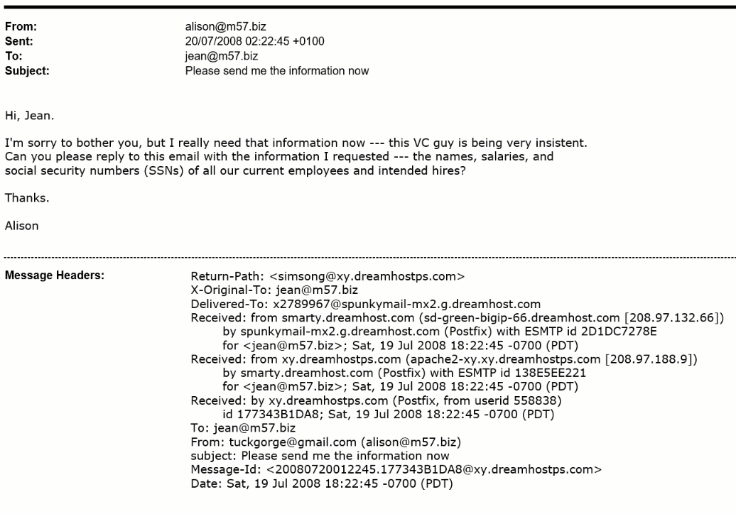

A

B

C

Figure 24 From Alison to Jean ‘Please send the information now’

As shown in Figure 24, the email discusses about providing a spreadsheet with employees and their details between Alison and Jean.

Both the Return-Path and the Message-ID match as an @xy.dreamhostps.com account. The email can be assumed to be untrustworthy as Alison’s company Message-ID ends in [alison@m57.biz](mailto:alison@m57.biz), whereas Message-ID of the Figure is [20080720012245.177343B1DA8@xy.dreamhostps.com](mailto:20080720012245.177343B1DA8@xy.dreamhostps.com).

The email can be assumed to have been sent by either her personal email, which could be [tuckgorge@gmail.com](mailto:tuckgorge@gmail.com) next to her work email, since the Message-ID of the Figure has already been used or it could have been a spam email from a third party.

Moreover, even though Received header A and B have the sender’s email address as xy.dreamhostps.com, Received header A does not have an IP address, whereas Received header B uses IP address 208.97.188.9, which can be checked using a DNS lookup to check the consistency of the connection. Received header A and B have different ids. Received header A has id 177343B1DA8, which cannot be tested, whereas Received header B has ESMTP id 138E5EE221. Reliability can be increased as it is a record of the device’s server. However, since Received header A and Received header B are inconsistent, it can be assumed the message has been sent by either her personal email address or as an untrustworthy spam email.

The Received header C and the Delivered-to header have the sender’s email address as dreamhost.com to send the message along with its IP address 208.97.132.66. The IP address is checked using a DNS lookup to check the consistency of the connection. ESMTP id 2D1DC7278E increases the reliability of the email as it is the record of the device’s server, even though it has been already established to be a spam email. Both X-Original-To header and To header are addressed to reach its destination, which is [jean@m57.biz](mailto:jean@m57.biz).

### 4.5.8 Email 8

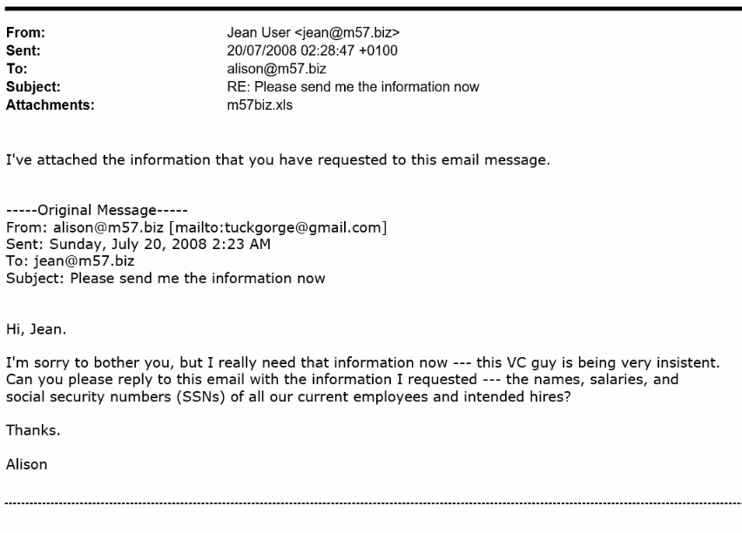

Figure 25: From Jean to Alison ‘Please send the information now’

Figure 25 represents communication about sending attachments of the company between Jean and Alison using their respective emails [jean@m57.biz](mailto:jean@m57.biz) and [tuckgorge@gmail.com](mailto:tuckgorge@gmail.com).

### 4.5.9 Email 9

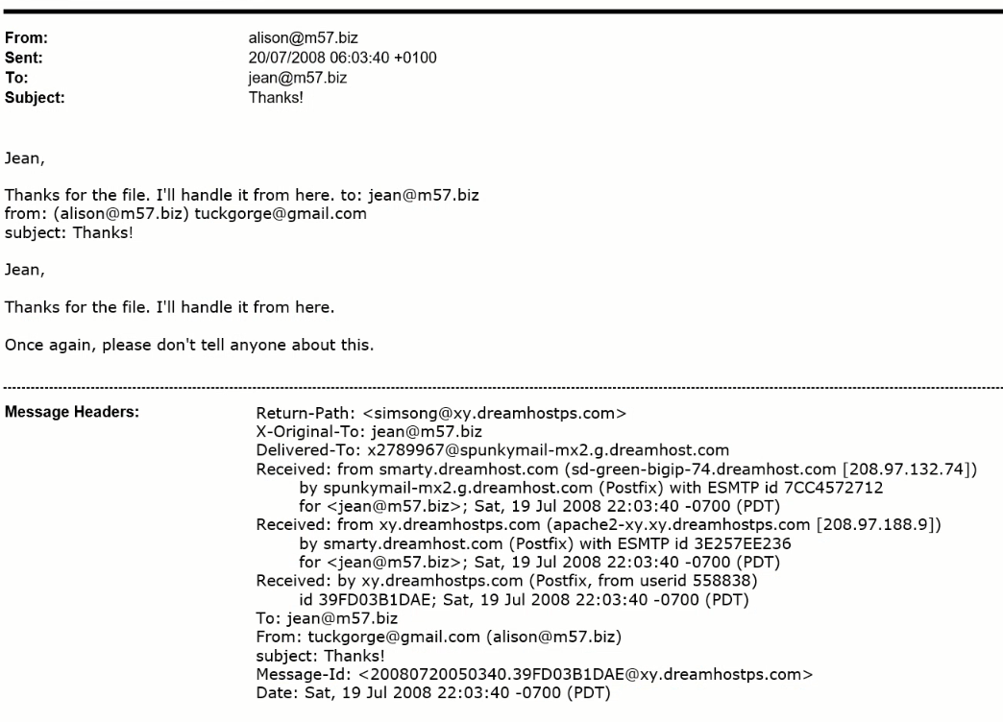

C

A

B

Figure 26: From Alison to Jean ‘Thanks’

As shown in Figure 26, the email discusses about providing a spreadsheet with employees and their details between Alison and Jean.

Both the Return-Path and the Message-ID match as an @xy.dreamhostps.com account. However, similarly to Figure 19, the email can be assumed to be untrustworthy as Alison’s company Message-ID ends in [alison@m57.biz](mailto:alison@m57.biz), whereas the Message-ID of the following Figure is [20080720050340.39FD03B1DAE@xy.dreamhostps.com](mailto:20080720050340.39FD03B1DAE@xy.dreamhostps.com). The email can be assumed to have been sent by either her personal email, which could be [tuckgorge@gmail.com](mailto:tuckgorge@gmail.com) next to her work email, since the Message-ID of the Figure has already been used or it could have been a spam email from a third party.

Moreover, even though Received header A and B have the sender’s email address as xy.dreamhostps.com, Received header A does not have an IP address, whereas Received header B uses IP address 208.97.188.9, which can be checked using a DNS lookup to check the consistency of the connection. Received header A and B have different ids. Received header A has id 39FD03B1DAE, which cannot be tested, whereas Received header B has ESMTP id 3E257EE236. Reliability can be increased as it is a record of the device’s server. However, since Received header A and Received header B are inconsistent, it can be assumed the message has been sent by either her personal email address or as an untrustworthy spam email.

The Received header C and the Delivered-to header have the sender’s email address as dreamhost.com to send the message along with its IP address 208.97.132.74. The IP address is checked using a DNS lookup to check the consistency of the connection. ESMTP id 7CC4572712 increases the reliability of the email as it is the record of the device’s server, even though it has been already established to be a spam email. Both X-Original-To header and To header are addressed to reach its destination, which is [jean@m57.biz](mailto:jean@m57.biz).

### 4.5.10 Email 10

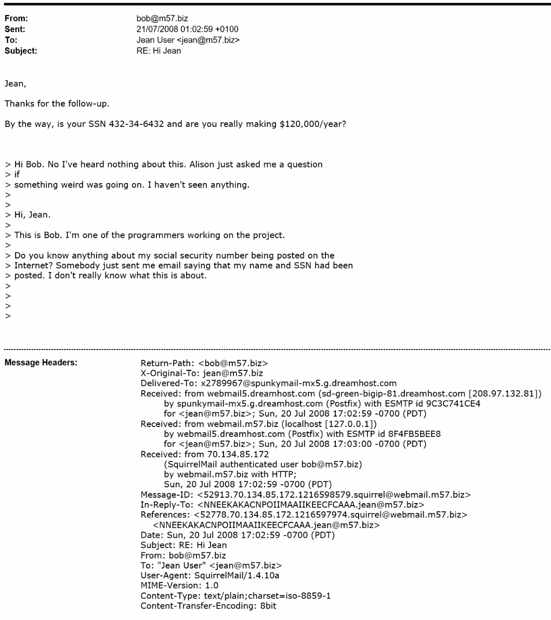

A

B

C

Figure 27: From Bob to Jean ‘Hi Jean’

Figure 27 shows the email discussion between Jean and Bob regarding Jean’s criminal record and salary.

Both the Return-Path and the Message-ID match as an @m57.biz account. If verified, Bob’s Message-ID can be identified as [52778.70.134.85.172.1216598579.squirrel@webmail.m57.biz](mailto:52778.70.134.85.172.1216598579.squirrel@webmail.m57.biz).

Due to Received header A using IP address 70.134.85.172 as a way to communicate and send information through the router, the message can be assumed to be an inconsistent spam email. DNS lookup can be used to check for consistency of the connection, but will not be useful. Moreover, there is no SMTP id.

Received header B uses the sender’s email address as webmail.m57.biz along with its IP address 127.0.0.1. The IP address is checked using a DNS lookup to check the consistency of the connection. SMTP id 8F4FB5BEE8 increases the reliability of the email as it is the record of the device’s server even though it has been already established to be a spam email.

The Received header C and the Delivered-to header have the sender’s email address as spunkymail-mx5.g.dreamhost.com to send the message along with its IP address 208.97.132.81. The IP address is checked using a DNS lookup to check the consistency of the connection. ESMTP id 9C3741CE4 increases the reliability of the email as it is the record of the device’s server, even though it has been already established to be a spam email. Both X-Original-To header and To header are addressed to reach its destination, which is [jean@m57.biz](mailto:jean@m57.biz). In-Reply-To header is [NNEEKAKACNPOIIMAAIIKEECFCAAA.jean@m57.biz](mailto:NNEEKAKACNPOIIMAAIIKEECFCAAA.jean@m57.biz) as it is a reply to Jean’s email address similar to Figures 21, 22 and 23.

MIME-Version is 1.0 and Content-type is text/plain. No documents have been attached.

### 4.5.11 Email Timeline

|  |  |  |  |  |  |
| --- | --- | --- | --- | --- | --- |
| Header | Date/Time | Subject | From | To | Message |
| Email 1 | 06/07/2008 at 20:25:10 | ‘business plan’ | alison@m57.biz | jean@m57.biz | Asking about the business plan |
| Email 2 | 20/07/2008 at 00:32:51 | ‘financial plans’ | alex@m57.biz | jean@m57.biz | Creating financial projections |
| Email 3 | 20/07/2008 at 00:39:57 | ‘background checks’ | jean@m57.biz | jean@m57.biz | Creating the file |
| Email 4 | 20/07/2008 at 00:50:21 | ‘which email address are you using?’ | Alex: alison@m57.biz | jean@m57.biz | Email is getting mixed |
| Email 5 | 20/07/2008 at 00:50:19 | ‘which email address are you using?’ | Alex: alison@m57.biz | jean@m57.biz | Email has been misconfigured |
| Email 6 | 20/07/2008 at 00:50:20 | ‘programmers’ | Alex: alison@m57.biz | jean@m57.biz | Programmers are not working |
| Email 7 | 20/07/2008 at 02:22:45 | ‘Please send me the information now’ | alison@m57.biz | jean@m57.biz | Asking to send the file |
| Email 8 | 20/07/2008 at 02:28:47 | ‘Please send me the information now’ | jean@m57.biz | alison@m57.biz | Sending the file |
| Email 9 | 20/07/2008 at 08:03:40 | ‘Thanks’ | [alison@m57.biz](mailto:alison@m57.biz) and [tuckgorge@gmail.com](mailto:tuckgorge@gmail.com) | jean@m57.biz | Handling the file |
| Email 10 | 21/07/2008 at 01:02:59 | ‘Hi Jean’ | bob@m57.biz | jean@m57.biz | SSN has been posted online |

Figure 28 Email's Timeline

## 4.6 Installed Programs and Recycle Bin

All installed programs found were either default applications or software used for managing financial information and for their sole business purposes only, such as the ‘Tencent’, ‘NetMeeting’, ‘Messenger’ and etc. With the installed programs, no information was found of any evidential value for the investigation to move forward.

The recycle bin is a location in a Windows desktop where the temporarily deleted files are stored. When an item is deleted from the hard disk, the icon of the recycling bin changes from full to empty, indicating the bin has been emptied. Even though, the user thinks the item is permanently deleted as it is no longer in the bin, Windows sends that item to the recycler bin. Whilst examining the recycle bin, it was discovered a file had been deleted from Jean’s computer. This was known because the information in the deleted recycle bin files indicated to be empty which was found in the following location:

* Partition 1 > NONAME (NTFS) > [root] > RECYCLER

The ‘RECYCLER’ directory contains the files that were deleted along with other metadata about the recycled files. There is a file called ‘INFO2’ which contains all the index files that were deleted, the original path and its file size. The original file path belonged in ‘Documents and Settings’ and was originally named ‘tag-cloud.jpg’. Deleted files would be renamed to Dc1 or similar once the recycle bin consumes the space in the hard disk. It was concluded that the jpg file that was deleted as it was not useful and therefore disregarded.

The filesystem present can also be indicated by the directory name of the recycle bin, as this is a NTFS windows partition. The directory folder where this information was found is called ‘RECYCLER’, whereas a FAT32 would have a directory name called ‘RECYCLED’.

## 4.7 Web Applications

Jean had last accessed her device on 21st July. However, having looked at the browser history which was accessed by Jean, Devon, and Administrator. The sites accessed were not relevant to the investigation because they consisted of, web messenger, windows update, Adobe Flash Player and mail searches by the Administrator. In addition, hotel bookings, webmail, eBay, leather bags and cigar, music albums, celebrity gossip searches were made by Jean.

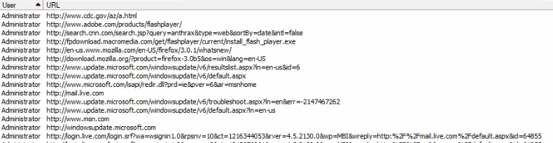

Figure 19 Administrators Browser search

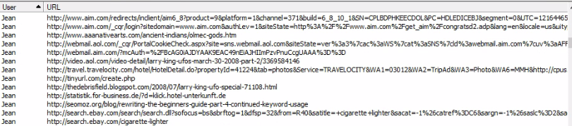

Figure 20 Jean’s Browser search

# **5 Summary of Findings**

The analysis conducted indicates the following:

**Finding 1:** The only people to have logged into Jean’s computer are Jean, Administrator and Devon. However, Devon’s last login occurred prior to the creation of the spreadsheet and is no longer listed as an employee of the company.

**Finding 2:** Jean, Admin and Devon’s accounts did not have passwords set, indicative that there was no encryption set in the first place, which compromised their accounts.

**Finding 3:** The recycle bin was found to have a deleted item, however it is unknown whether the deleted item is related to the investigation.

**Finding 4:** Three spreadsheets containing the leaked information was found. Two being present in email files, one physically stored on the hard drive, and its MS Office and file systems metadata differ.

**Finding 5:** An image was found on the spreadsheet and its origin could not be determined, because it was not found separately within hard drive.

**Finding 6:** Jean was the last user listed as accessing the spreadsheet.

**Finding 7:** Jean received an email about financial projections from Alex, who is an unknown person.

**Finding 8:** Alison had asked Jean to provide employee data, their salaries and their SSN information using an irregular Message-ID ending in @xy.dreamhostps.com, instead of the usual Message-ID ending in @57.biz.

**Finding 9:** Alison stated by email that her email had been misconfigured from [alex@m57.biz](mailto:alex@m57.biz), instead of [alison@m57.biz](mailto:alison@m57.biz) to Jean.

**Finding 10:** The last user to use Jean’s computer was Administrator on 21st July and used AIM Messenger.

# **6 Conclusion**

After conducting the investigation, these are the recommendations:

**How did the documents get on the competitor's website?**

Emails between Jean and Alison were discovered that requested the spreadsheet to be created and sent. The evidence suggests Alison’s emails have been spoofed and could possibly have come from unknown entities, [alex@m57.biz](mailto:alex@m57.biz) and [tuckgorge@gmail.com](mailto:tuckgorge@gmail.com). These may be linked to the competitor. This is the only evidence found where the spreadsheet has left M57.Biz’s premises.

**When did Jean create this spreadsheet?**

The spreadsheets indicate discrepancies between MS Office and the files system’s metadata. As the file system information comes from registry data, this is the one that should be taken as correct, as it states that the create time was “20/07/2008 02:28:03 (2008-07-20 01:28:03 UTC)”.

**Who else from the company is involved?**

The evidence collected only links to Jean and Alison, with no other mentions of anyone else at the company. Although both deny their involvement, Jean’s computer has been accessed and the spreadsheet tampered with. This could have been done without her knowledge or help but the evidence is insufficient to completely exempt her from liability.

Similarly, it is Alison’s emails that have been spoofed. Even though there is evidence of this, it does not prove she has been involved. Further investigation into Alison’s devices may aid in excluding her as a suspect.

There is no evidence to suggest anyone else currently in the list of employees is involved in this incident.

# **7 References**

Forensic Notes, 2021. ISO 17025 – Right for Digital Forensics?. [Online]   
Available at: https://www.forensicnotes.com/iso-17025-right-for-digital-forensics/  
[Accessed 11 04 2021].

Gov.uk, 2020. Police and Criminal Evidence Act 1984 (PACE) codes of practice. [Online]   
Available at: https://www.gov.uk/guidance/police-and-criminal-evidence-act-1984-pace-codes-of-practice   
[Accessed 11 04 2021].

ISO, 2021. ISO/IEC 27037:2012 Information technology — Security techniques — Guidelines for identification, collection, acquisition and preservation of digital evidence. [Online]   
Available at: https://www.iso.org/standard/44381.html  
[Accessed 11 04 2021].

The National Archives, 2021. Police and Criminal Evidence Act 1984. [Online]   
Available at: https://www.legislation.gov.uk/ukpga/1984/60/contents  
[Accessed 11 04 2021].

Wikipedia, 2021. Raising the Flag on Iwo Jima. [Online]   
Available at: https://en.wikipedia.org/wiki/Raising_the_Flag_on_Iwo_Jima  
[Accessed 11 04 2021].

# **8 Appendices**

The appendices contain all relevant documents and information to our investigation. Some parts may have been used throughout the report.

### Appendix A – SEARCH WARRANT

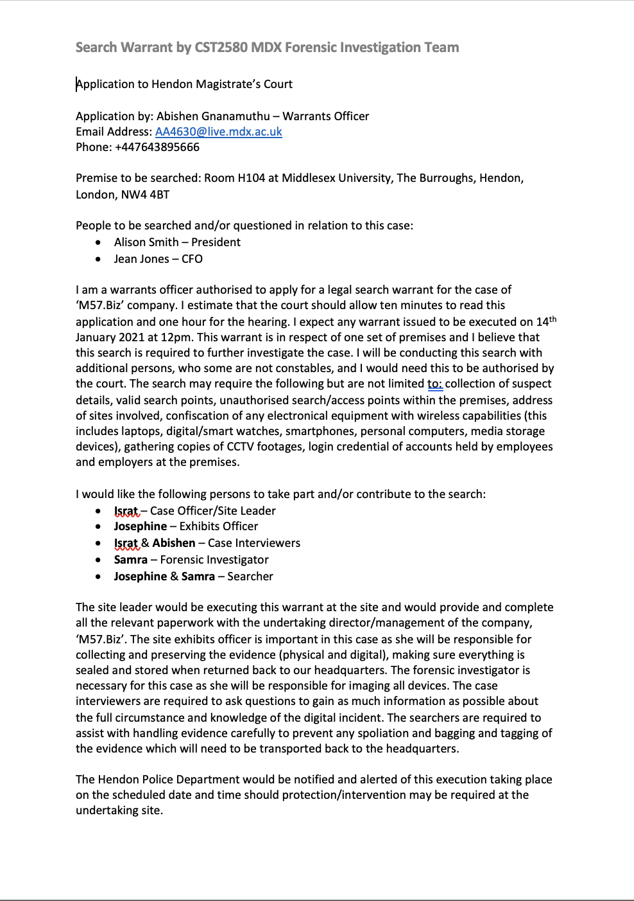

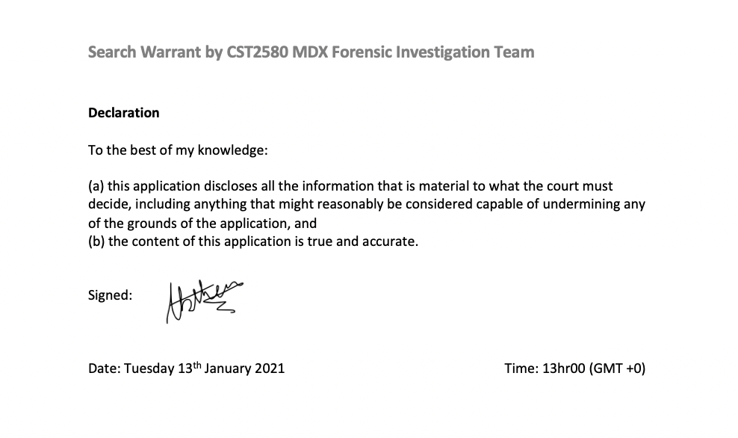

### Appendix B – CHAIN OF CUSTODY FORM FOR USB

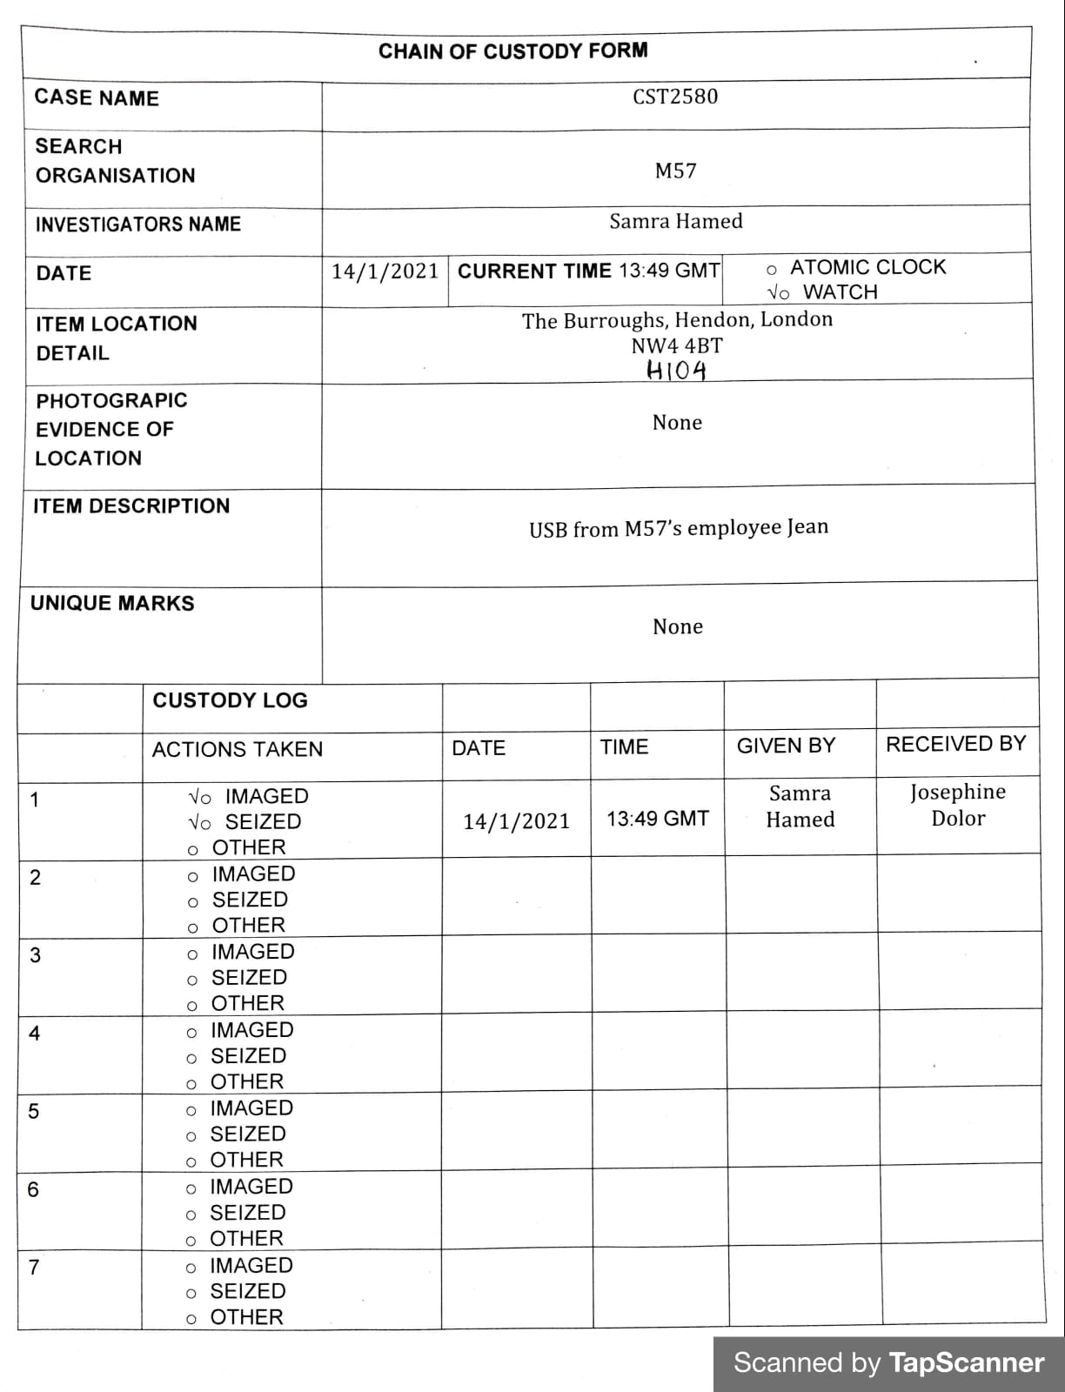

### Appendix C – CHAIN OF CUSTODY FORM FOR HARD DRIVE

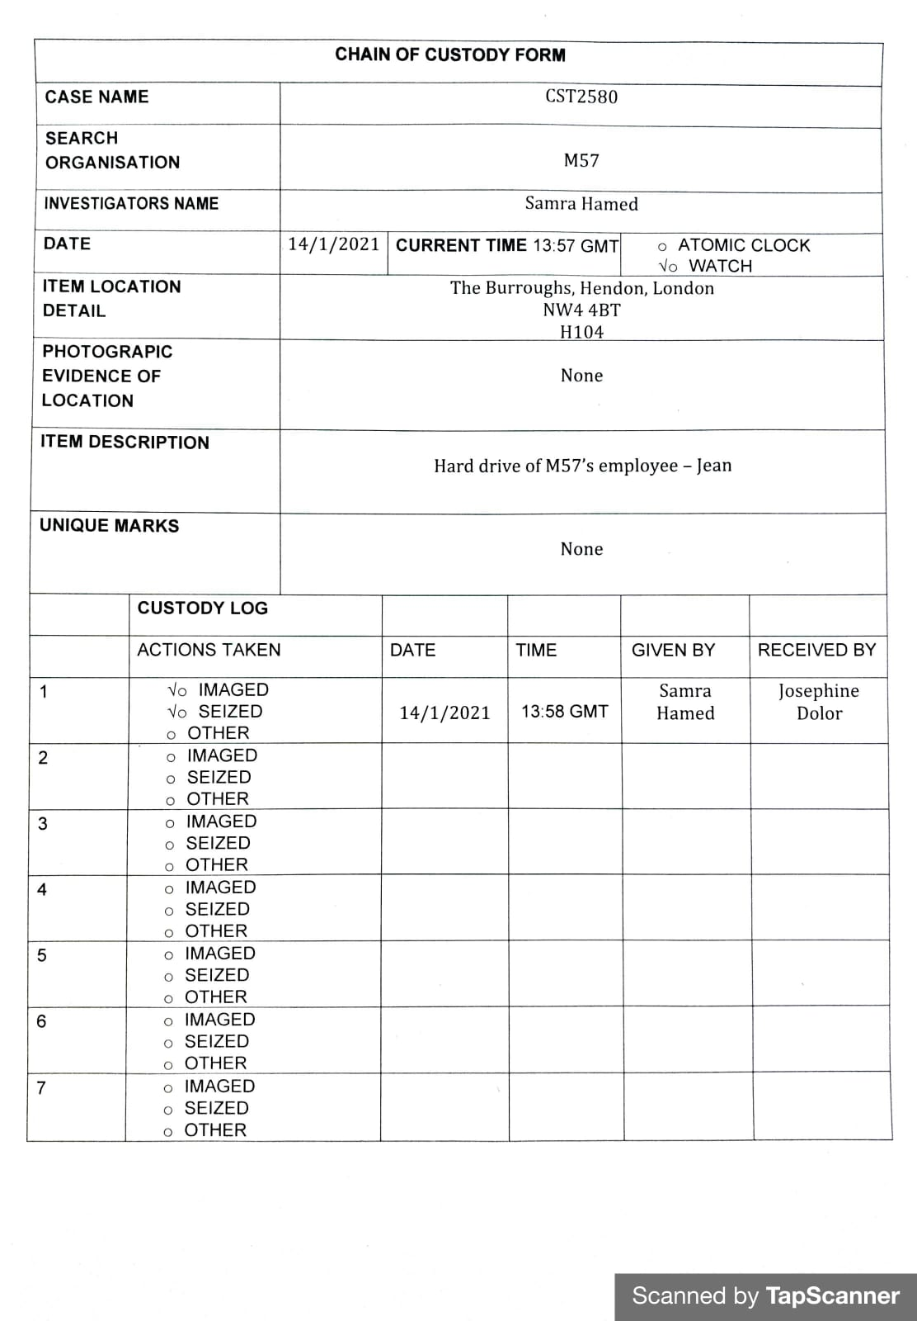

### Appendix D – DISK ACQUISITION FORMS

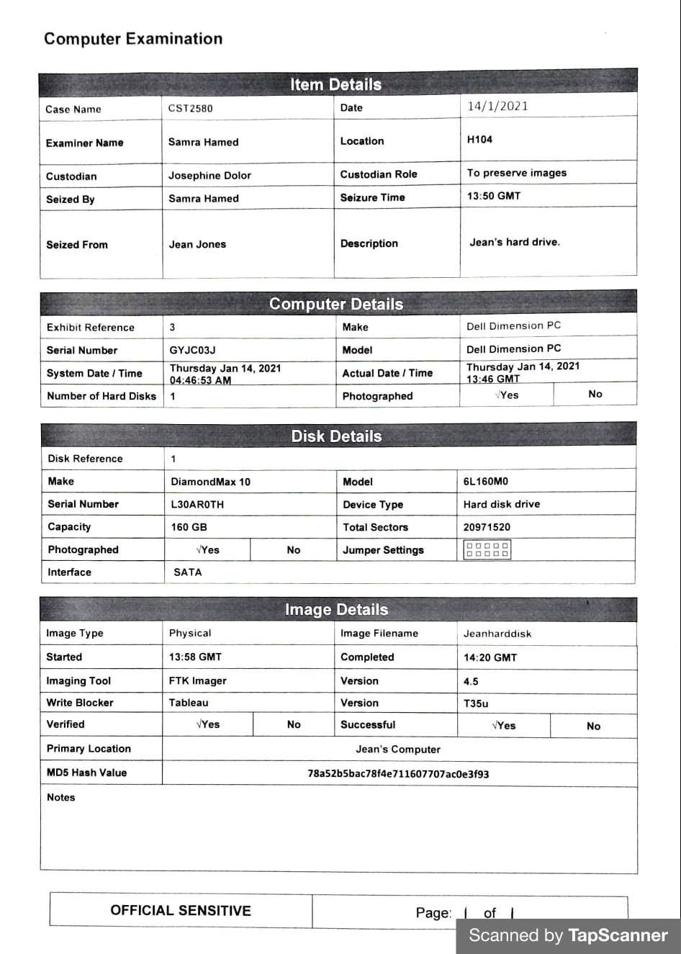

### Appendix E – HARD DISK ACQUISITION FORM

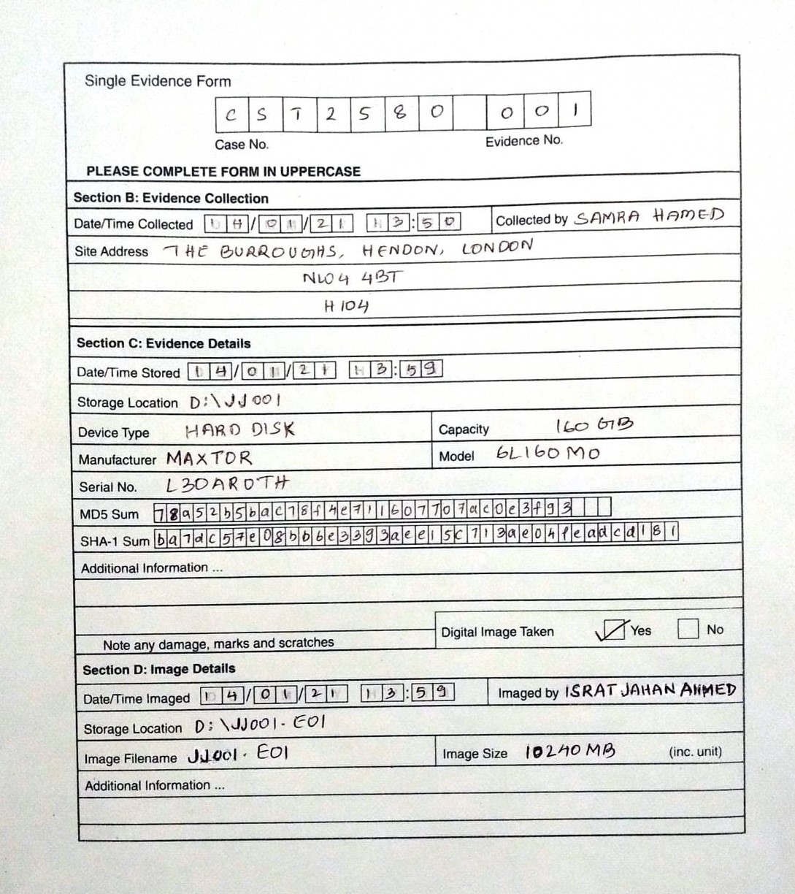

### Appendix F – USB ACQUISITION FORM

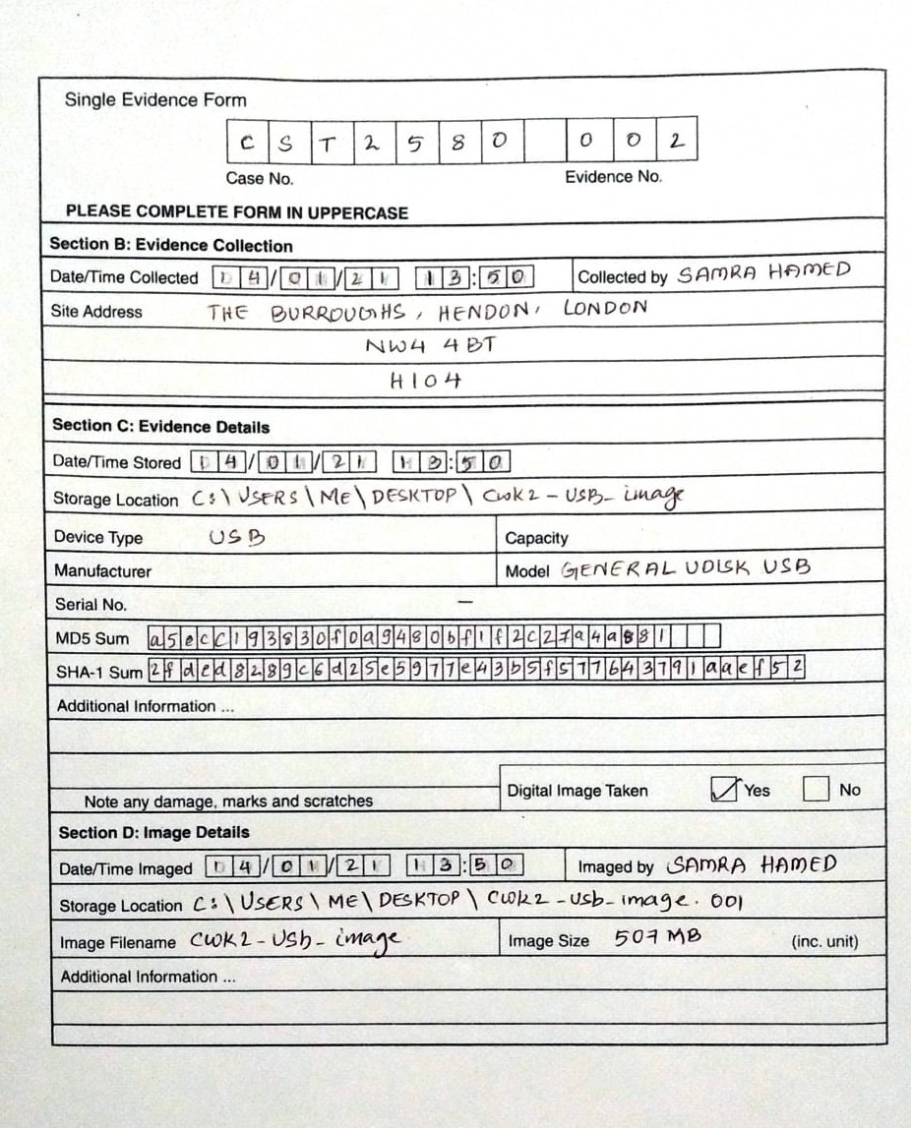

### Appendix G – JEAN’S HARD DRIVE IMAGE SUMMARY

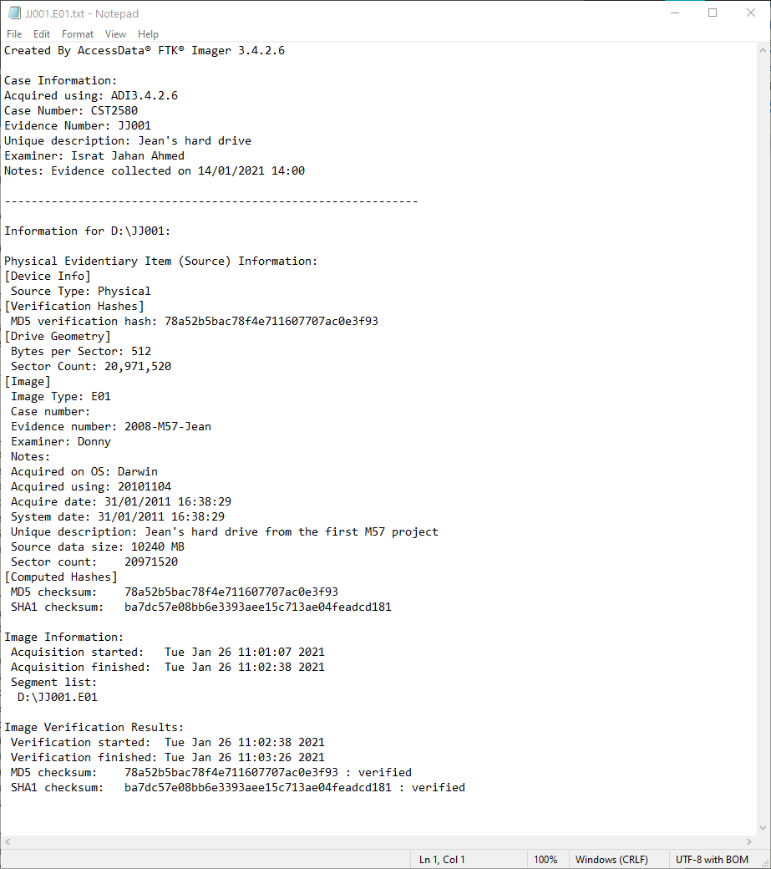

### Appendix H – JEAN’S USB IMAGE SUMMARY

